Questions

JAVA

1. Find unique strings in an array of strings?

Input

strArray = {“abc”, “def, “ABZ”, “ASD”, “AbC”};

Similar strings - include case insensitive

output - “abc”, “def”,”ABZ”,”ASD”

Ans:
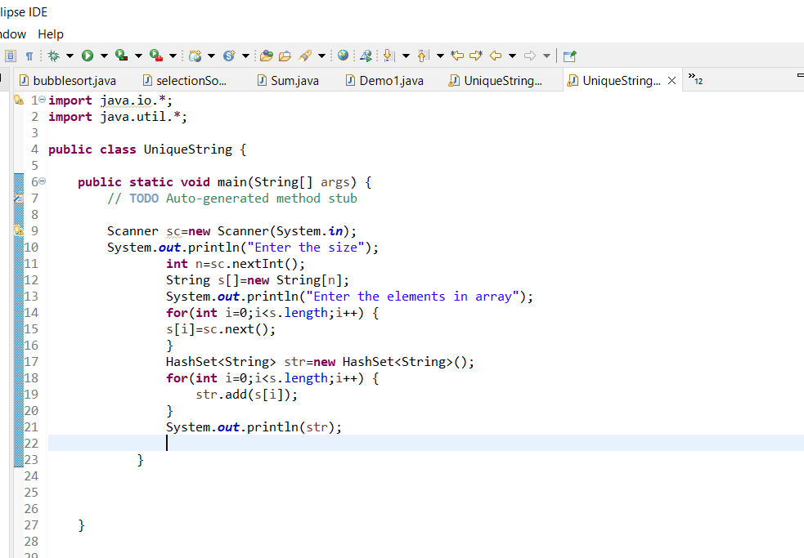

2. Write a program in Java to create an abstract class market. There are two methods getPrice() and getProductName() as abstract method.

Ans:
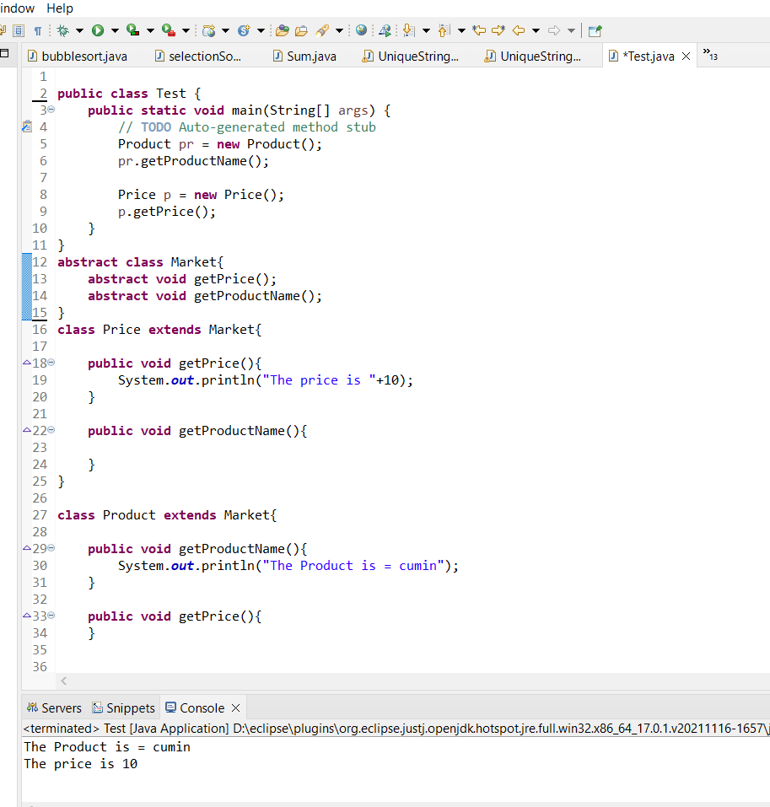

3. Write a program in Java to find 2nd largetst number in an array of Strings ?

Ans:
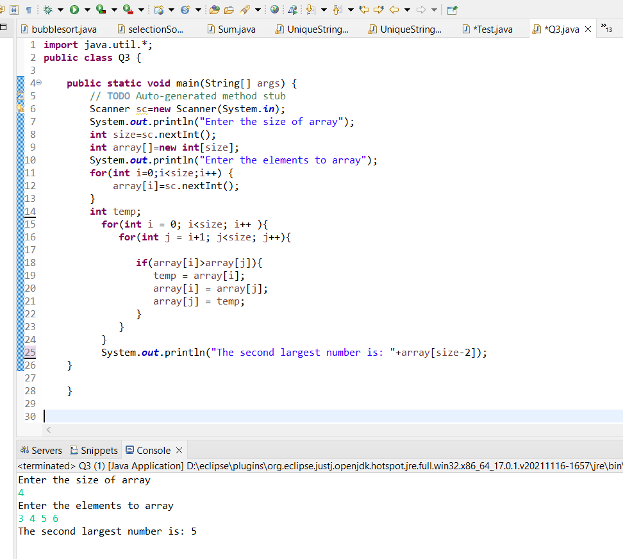

4.Write a program in Java to find pair of numbers whose sum is a number present in an array of integers?

Example - { 2, 5 ,8 ,9, 0,1, 7 , 10}

Output - (2,5), (9,1) ,(0,1)

Ans:
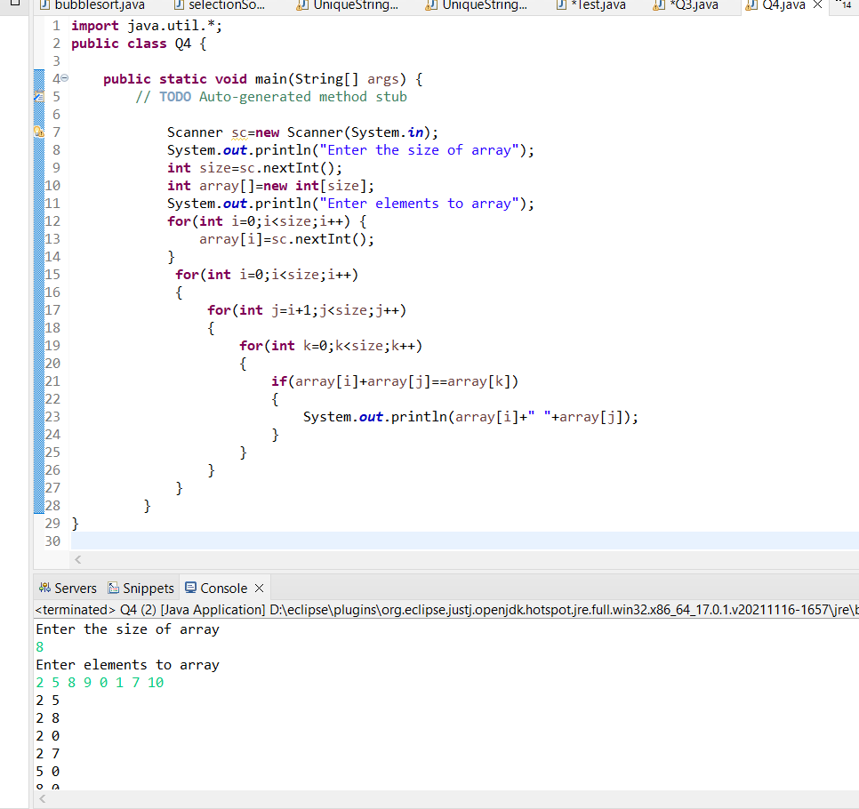

SQL

1). create and execute the sql in the tables(mentioned below)

Tables
Subject ( id , rollno, subjectname , marks)

Student (id, rollno, sname, address )

Write a SQL query to find the count of all students studying a paticular subject?

Write a SQL query to find total marks of a particular student for all subjects?
Ans:
CREATE TABLE Subject(
id VARCHAR(10) PRIMARY KEY,
rollno INT,
subname VARCHAR(20),
marks INT
);
CREATE TABLE Student(
id VARCHAR(10),
rollno INT,
sname VARCHAR(20),
address VARCHAR(50),
FOREIGN KEY(id) REFERENCES Subject(id)
);
INSERT INTO Subject VALUES('A001', 2863, 'Maths', 80);
INSERT INTO Subject VALUES('A002', 2864, 'Physics', 90);
INSERT INTO Subject VALUES('A003', 2865, 'Chemistry', 50);
INSERT INTO Subject VALUES('A004', 2866, 'Biology', 70);
INSERT INTO Subject VALUES('A005', 2867, 'History', 60);

INSERT INTO Student VALUES('A003', 2865, 'Yash', 'bbsr');
INSERT INTO Student VALUES('A004', 2866, 'Aman', 'jsg');
INSERT INTO Student VALUES('A004', 2866, 'Ayush', 'jsr');
INSERT INTO Student VALUES('A001', 2863, 'Harsh', 'sng');

SELECT subname, COUNT(id) AS 'Total Students' FROM Subject
WHERE subname = 'Biology'
GROUP BY subname;

SELECT SUM(marks) AS TotMarks FROM Subject, Student
WHERE Subject.id = Student.id
AND sname = 'Aman';

2)

product(id, name , price ,location)

manufacturer( id, company_name, product_id, address)

Write a SQL query to find company_name of a particular product and location given input as product _id?

(Use Join statements)

Ans:

CREATE TABLE Product(
id INT PRIMARY KEY,
name VARCHAR(30),
price INT,
location VARCHAR(30)
);

CREATE TABLE manufacturer(
id INT,
company_name VARCHAR(30),
product_id VARCHAR(5),
address VARCHAR(20),
FOREIGN KEY(id) REFERENCES Product(id)
);

INSERT INTO Product VALUES(1, 'Yash', 100, 'bbsr');
INSERT INTO Product VALUES(2, 'Aman', 200, 'jsg');
INSERT INTO Product VALUES(3, 'Anurag', 50, 'jsr');
INSERT INTO Product VALUES(4, 'Ayush', 300, 'sng');
INSERT INTO Product VALUES(5, 'Harsh', 70, 'bjr');

INSERT INTO manufacturer VALUES(2, 'Virtusa', 'A01', 'khandagiri');
INSERT INTO manufacturer VALUES(3, 'Microsoft', 'A02', 'Patia');
INSERT INTO manufacturer VALUES(3, 'Hexaware', 'A03', 'Udaygiri');
INSERT INTO manufacturer VALUES(1, 'Informatica', 'A04', 'Jagmohan Nagar');
INSERT INTO manufacturer VALUES(4, 'Meta.net', 'A05', 'Bapujinagar');

SELECT company_name FROM Product, manufacturer
WHERE Product.id = manufacturer.id
AND product_id = 'A02';

HTML

Design an html page with following layout as mentioned below (Include CSS as mentioned in diagram color) include table inside content section

<!DOCTYPE html>
<html lang="en">
<head>
<meta charset="UTF-8" />
<meta http-equiv="X-UA-Compatible" content="IE=edge" />
<meta name="viewport" content="width=device-width, initial-scale=1.0" />
<link rel="stylesheet" href="task.css" />
<title>TASK 1</title>
<link
rel="stylesheet"
href="https://cdn.jsdelivr.net/npm/bootstrap@4.1.3/dist/css/bootstrap.min.css"
integrity="sha384-MCw98/SFnGE8fJT3GXwEOngsV7Zt27NXFoaoApmYm81iuXoPkFOJwJ8ERdknLPMO"
crossorigin="anonymous"
/>
</head>
<body>
<div class="row">
<div class="col-lg-2" style="background-color: red; border: 1px solid">
<img src="logo.jpg" alt="img" height="100px" width="200px" />
</div>
<div class="col-lg-10" style="background-color: green; border: 1px solid">
<h1 class="site_name">ABC site</h1>
</div>

</div>
<div class="row2">
<div
class="col-9"
style="
background-color: aqua;
border: 1px solid;
margin-left: 350px;
height: 500px;
"
>
<h1 class="content">content</h1>
<table>
<tr>
<th>product_id</th>
<th>product_name</th>
<th>price</th>
<th>location</th>
</tr>
<tr>
<td>1</td>
<td>A</td>
<td>100</td>
<td>BBSR</td>
</tr>
<tr>
<td>2</td>
<td>B</td>
<td>200</td>
<td>BBSR</td>
</tr>
</table>
</div>
</div>
<div class="row3">
<div
class="col-12"
style="background-color: green; border: 1px solid; height: 60px"
>
<h1 class="footer">Footer</h1>
</div>
</div>
</body>
</html>

Table-1
product_id | product_name | price | location

SITE NAME

Signup

Home

Product

Help
CONTENT
FOOTER
LOGO

